SIMATS ENGINEERING (SAVEETHA SCHOOL OF ENGINEERING)
Department of Computer Science and Engineering

ASSESSMENT TOOL 1– Concept Mapping

Course Code: | CSA0312 | Course Title: | Data Structures
CO Assessed: | CO1 – Imitation (BL3, BL4) | Assessment: | Assessment Tool 1 – Concept Mapping
Weightage: | 10% of CIA | Total Marks: | 100
CO1 Statement: | Basics, Data, Data object, Data structure, Abstract Data Types (ADT), realization of ADT in ‘C’, Primitive and non-primitive data structure, Linear and non-linear data structure Arrays & Recursion, Performance analysis and Measurement: Time and space analysis of algorithms, Average, best and worst-case analysis.
Student Name: | S. Priyanka | Reg. No.: | 192424033
Section / Batch: |  | Date: | 27-07-2026
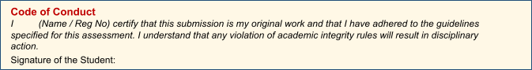
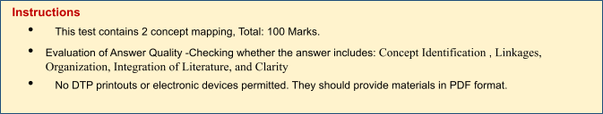

Rubrics

Questions | Problem Understandin g | Method Selection | Solutio n Process | Accuracy of Calculation | Interpretation of Results | Total Marks
Q1
Q2

Annexure A – Concept Mapping

Questions: | EACH QUESTIONS CARRIES : 10 MARKS Duration :ONE HOUR

Q3 E-commerce platform manages product storage, searching, and recommendation systems. Construct a concept map linking Linear Data Structures → Sequential Access → Limitations → Non-Linear Data Structures → Hierarchical/Network Relationships → Applications. Analyze the differences between linear and non-linear structures and demonstrate how each supports specific components of the system. Justify which structure is more efficient for handling complex applications.

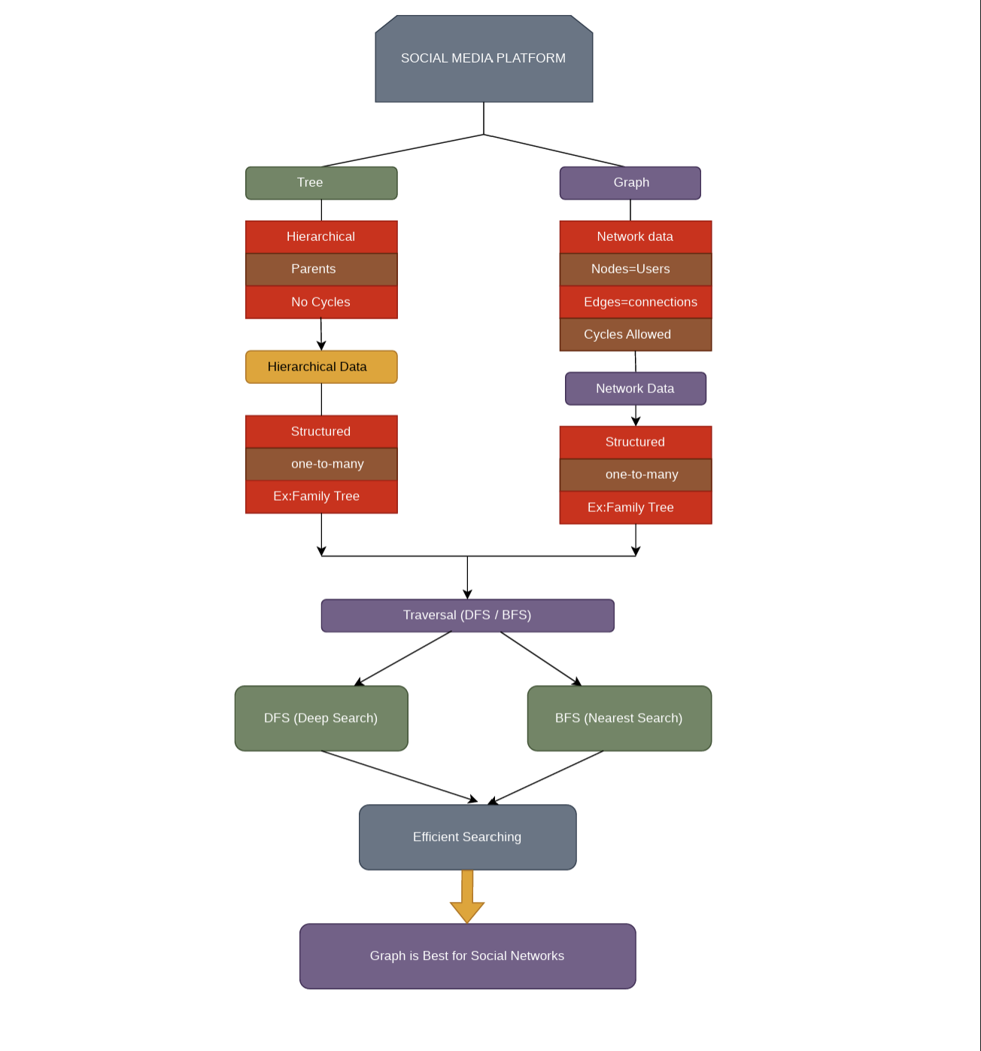
Q20 A video streaming application must balance speed and memory usage. Construct a concept map connecting Time Complexity → Space Complexity → Tradeoff → Algorithm Design → Performance Optimization. Analyze how improving one factor affects the other and justify the optimal balance.
